State Council of Higher Education for Virginia
Program Proposal Cover Sheet

1. Institution  George Mason University | 2. Program action (Check one):  Spin-off proposal  New program proposal
3. Title of proposed program  Chemistry and Biochemistry |  |  | 4. CIP code
5. Degree designation: Ph.D. |  | 6. Term and year of initiation: Fall, 2009
7a. For a proposed spin-off, title and degree designation of existing degree program

7b. CIP code (existing program)
8. Term and year of first graduates  May, 2014 |  | - Date approved by Board of Visitors
10. For community colleges:
date approved by local board
date approved by State Board for Community Colleges

- If collaborative or joint program, identify collaborating institution(s) and attach letter(s) of intent/support from corresponding chief academic officers(s)

- Location of program within institution (complete for every level, as appropriate).
School(s) or college(s) of |  | Chemistry and Biochemistry Department, College of Science
Division(s) of
Campus (or off-campus site) |  |  | Fairfax and Prince William
Distance Delivery (web-based, satellite, etc.)

- Name, title, telephone number, and e-mail address of person(s) other than the institution’s
chief academic officer who may be contacted by or may be expected to contact Council staff
regarding this program proposal.

Gregory Foster, Chair,
703.993.1070
gfoster@gmu.edu

Table of Contents

Description of the Proposed Program 1
Overview 1
Curriculum 3
Faculty 7
Departmental Resources 7
Assessment 8
Benchmarks of Success 9
Expansion of an Existing Program 9
Collaborative or Standalone Program 10
Justification for the Proposed Program 10
Response to Current Needs 10
Spin-off Proposal 11
Employment Demand 12
Student Demand 14
Duplication 17
Projected Resource Needs 18
Appendices 24
Appendix A – Letter of Support from Dean of College of Science 24
Appendix B– Sample Schedules for a Ph.D. in Chemistry and Biochemistry 25
Appendix C – “Mini CV’s” for Faculty 26
Appendix D – Departmental Faculty Research 28
Appendix E – Sample Survey Instrument 32
Appendix F – List of Ph.D.s Granted with Chemistry Department Advisor 34
Appendix G. – Letters of Support from Current and Admitted PSCI Ph.D. students 35
Appendix H – Letter of support from Alumni 43
Appendix I – Job Announcements below. 44

Description of the Proposed Program

Overview
The Department of Chemistry and Biochemistry at George Mason University proposes to offer the Ph.D. in Chemistry and Biochemistry beginning in the fall of 2009. The program is designed to provide students a firm foundation in advanced coursework followed by an independent research project under the guidance of a faculty mentor. The program culminates in a dissertation and body of research that is publishable in a peer-reviewed scientific journal.
The program goals are to:
- Educate students at the doctoral level by providing them advanced coursework and research opportunities.
- Perform research that will advance the field of chemistry/biochemistry.
- Increase external funding through productive research in critical fields of chemistry and biochemistry.
- Enhance the employment opportunities of students by providing them with skills that will be valuable to themselves, the state, and the country.
- Enhance the economy of the state – especially northern Virginia – by producing well-trained individuals who will be competitive in critical fields (such as water sustainability and analysis and Biochemical research) of importance to the state.
- Enhance the stature of George Mason by being the center of cutting edge research in the chemical and biochemical sciences for northern Virginia.

Need for a Chemistry and Biochemistry Doctoral program. George Mason University (GMU) is the only major Virginia-supported school located in northern Virginia and it is well positioned to provide advanced instruction to students interested in Chemistry or Biochemistry. This year, U.S. News & World Report named Mason the number one national university to watch on its list of "Up-and-Coming Schools." Mason was cited as a school that has recently made the most promising and innovative changes in academics, faculty, students, campus or facilities.
There is presently no disciplinary doctoral program in the areas of chemistry and biochemistry. In many ways, Chemistry and Biochemistry are thought of as the central sciences that bridge the other sciences. It is inconceivable that GMU could advance in national-rankings without providing advanced training in Chemistry and Biochemistry.
The northern Virginia/DC metropolitan area is a major employer of chemists and biochemists. They are employed at all of the major government laboratories in the area, such as National Institutes of Health, National Institute of Science and Technology, Naval Research Laboratory and National Aeronautics and Space Administration. A large number of companies in the area also employ chemists and/or biochemists, including American Type Culture Collection, Scientific Applications International Corporation and many others as outlined later in the proposal. Many of the chemists/biochemists at these places require doctoral training for career advancement. Since there is no disciplinary Ph.D. program in northern Virginia, students wanting (or needing) training at this level must either enroll in a doctoral program in Washington D.C. or Maryland where they are required to pay burdensome out–of–state tuition rates. Northern Virginia needs a disciplinary based doctoral program in the chemical/biochemical sciences to meet the needs of these individuals as it does in all of the other major disciplinary areas of math and science. Although students have enrolled in other Ph.D. programs (especially the Environmental Science and Public Policy program (ESPP) within GMU for several years under the supervision of faculty from the Department of Chemistry and Biochemistry, they clearly would have preferred to be in a program offered by the department.

PSCI program does not meet students’ needs. The Physical Sciences Ph.D. program began in 2005 as an interdisciplinary program to meet the need of students for advanced training in astronomy, biochemistry, chemistry and physics. Enrollment in the program was quite reasonable with 34 students in the program as of spring of 2008. The program required students to take courses across the disciplines, but there was significant resistance from the students; they apparently mostly identified themselves with the individual disciplines and wanted to work in those areas. The Physics department having the largest number of students in the program decided to write a disciplinary Ph.D. proposal - which was approved - to start in Fall 2008.

Chemistry oriented students have been even less-satisfied with the program. They prefer the more traditional degree because most employers identify the expertise of a degree holder in chemistry or biochemistry, the essential brand names of these scientific disciplines. This is especially true for an upcoming university like George Mason University that does not yet have the “name” recognition of some of the more readily identifiable research universities, and degree recognition is important in competition for jobs. Most students also seem to identify PSCI as a brand of physics, and one that chemists do not typically search out on the Internet. As a result, enrollment in PSCI has been biased towards more traditional Physics oriented students, although applications from chemistry/biochemistry oriented students to the PSCI program increased by about a factor of two in the past year as students discovered that the department was preparing a proposal for a disciplinary program. They have told faculty members that they would transfer to the new program when (if) it was approved.

With Physics no longer participating in the formerly joint program, and students un interested in the PSCI program if something else were available, it is apparent that a discipline based program in chemistry and biochemistry is strongly recommended. We intend to eliminate the PSCI degree and replace it with a new Ph.D. in chemistry and biochemistry. The proposed new degree will be the primary program for students seeking doctoral training in the chemical/biochemical sciences. The end result for the University will be no net increase in Ph.D. programs once the PSCI program is eliminated. This will occur after students presently in the PSCI program either transfer to the discipline based degree or graduate. The advantage of the new program, however, will be that GMU and the Department of Chemistry and Biochemistry will be able to better serve the citizens of Northern Virginian.

Department and departmental resources. The Department of Chemistry and Biochemistry has an established record of success in graduate education. The department currently offers a Master’s degree in Chemistry and an accelerated BS/MS degree in Chemistry. The Master’s degree has been active and successful in the department since 1987 and over 100 M.S. degrees have been awarded through both M.S. programs. Besides the M.S. degree in Chemistry, faculty members are also involved with several interdepartmental Ph.D. degree programs. George Mason is classified as a Research Intensive-Ph.D. granting university. A new College of Science was established in 2006, and external research funding at the university is growing rapidly. Chemistry faculty are active in advising Ph.D. students using primarily the interdisciplinary ESPP Ph.D. program, and more recently the PSCI Ph.D. program. Prior to 2005, chemistry students enrolled in the ESPP Ph.D. program because of the lack of a Chemistry Ph.D. Over the last 10 years a total of 16 Ph.D. degrees in ESPP with a chemistry orientation have been granted.

The faculty members in the Department of Chemistry and Biochemistry have established numerous research collaborations across different schools, colleges and departments at GMU. Cross-disciplinary research projects involving Chemistry Ph.D. students are critical to the success of other academic units. For example, the Center for Clean Water and Sustainable Technologies, which resides in the Department of Chemistry and Biochemistry, is a collection of departmental researchers working on various aspects of developing methods of chemical analysis and water remediation. It draws upon the groundbreaking work of Dr. Abul Hussam on the development of a simple apparatus which removes arsenic from water. Chemistry related research is an essential gear in the Mason research machine that is fueling economic development in the northern Virginia region. For example, the Department of Chemistry and Biochemistry averaged $950k/yr in grants and contracts from 2004-2007, along with an average of 22 publications/yr during the same period. For a department with an averages teaching load of 2 courses per semester per faculty member, this shows a strong research commitment by the faculty. Besides grant resources, the department has a significant inventory of research grade instrumentation as well as access to other instrumentation at GMU and other local institutions. Finally, a total of 10 graduate teaching assistants are available to support full-time students.

Curriculum
The proposed program in Chemistry and Biochemistry comprises 72 credits, distributed among the following categories of courses: core courses (12 credits), research methods (3 credits), seminar (3 credits), electives (30 credits), and dissertation proposal and dissertation research (24 credits).

Curriculum: In order to address the cross-disciplinary nature inherent in chemistry research, the doctoral program in Chemistry and Biochemistry at George Mason University provides considerable flexibility in the courses that a student may take to satisfy the core course requirements. The program relies on faculty advisors (academic/research advisor and dissertation committee) playing an active role in the training of students, advising them on courses that they should take and advising them in the course of their research. As soon as possible during their first semester, students should discuss their research interests with faculty members, select a research/dissertation advisor (with the advisor’s consent) and establish their research/dissertation committee.

- Summary of Requirements
As described in the general doctoral requirements of George Mason University, all students in the Chemistry and Biochemistry Doctoral program must earn a minimum of 72 graduate credits, of which, 48 credits must consist of course work and preliminary research credits. Dissertation Proposal and Dissertation Research (CHEM 998 and 999) provide the remaining 24 credits.

For students entering the doctoral program with a master of science degree, the number of credits required may be reduced by a maximum of 30 with approval of the advisor and the program director. Graduate credits taken previously and not used toward another degree may be transferred, subject to the approval of the advisor, the program director, and the dean.

- Required Courses
Advising: Upon acceptance into the Chemistry and Biochemistry Ph.D. program at George Mason University, a student will be assigned an academic advisor. Prior to registering for classes, students are required to meet with their academic advisors who will provide guidance in selecting courses that are consistent with the student’s area of interest. Once a student has selected a research/dissertation advisor, that person then assumes the role of providing academic advising to the student.

Core: All students will be required to take 12 credits in graduate level chemistry core courses. Approved core courses are given in Table 1. Of these classes, no more than two within the same chemistry sub-discipline (i.e. Analytical, Biochemistry, Environmental, Inorganic, Organic and Physical) may be applied towards the required 12 credits. In addition to these courses, students will be required to take 3 credits of Graduate Seminar (CHEM 790) for 1 credit per semester, and 3 credits of Graduate Research Methods and Presentation (CHEM 791).

Table 1 Courses that can be applied to meeting the “core” course requirement.
CHEM 728 Introduction to Solid Surfaces | Analytical
CHEM 625 Electroanalytical Chemistry | Analytical
CHEM 660 Protein Biochemistry | Biochemistry
CHEM 665 Protein-Protein Interactions: Meth/Analy | Biochemistry
CHEM 624 Principles of Chemical Separations | Environmental
CHEM 651 Environmental Chemistry of Organic Chemicals | Environmental
CHEM 646 Bioinorganic Chemistry | Inorganic
CHEM 741 Solid State Chemistry | Inorganic
CHEM 613 Modern Polymer Chemistry | Organic
CHEM 617 Organic Structural Spectroscopy | Organic
CHEM 633 Chemical Thermodynamics and Kinetics | Physical
CHEM 735 Astrophysical Chemistry of Planetary Bodies | Physical

Electives: A student may choose up to 30 credits in general elective graduate courses that can be applied towards the degree requirements with the approval of the dissertation advisor and the program director. Core courses not used to satisfy the core requirement can be used as elective credits.

A summary of the course requirements is provided below.

Course | Credits
Chemistry Core | 12
Electives | 30
CHEM 790(Seminar) | 3
CHEM 791 | 3
Chem 998/999 (Dissertation) | 24
Total | 72

- Formation of Dissertation Committee
Before the end of their first year, students in the program are expected to have selected a dissertation/research supervisor and to have formed their dissertation committee. This committee will consist of at least 4 graduate faculty members (including the dissertation supervisor), with at least 2 members being faculty in the Department of Chemistry and Biochemistry. The remaining 2 may come from outside of the Department of Chemistry and Biochemistry at George Mason University. Qualified individuals who are not members of the graduate faculty, including faculty at other universities or comparable institutions, may serve on the committee with the approval of the program director and the associate dean for graduate programs. The dissertation advisor may serve as chairman of the dissertation committee or another committee member may be selected by the student with the approval of the program director. Furthermore, the composition of the dissertation committee must be approved by the program director.

After the dissertation committee is formed, students are required to meet with their committee at least once every 12 months. At these meetings, the student will provide a progress report to the committee on the status of their project and/or course work. The committee is expected to evaluate the student and provide advice and suggestions.

- Research Proposal, Qualifying Exams and Advancement to Candidacy
Advancement to candidacy may be approved for the student following the completion of coursework along with the following additional requirements.
- The student will be required to prepare a detailed written proposal describing the dissertation research. The proposal must be approved by the dissertation committee.
- The student must successfully complete separate written and oral qualifying examinations prepared and administered by members of the dissertation committee.

Following completion of the research proposal and qualifying exams, the committee will recommend the student for advancement to candidacy by the Dean or provide alternative recommendations to the student.

- Doctoral Dissertation
Based upon the committee’s familiarity with the student’s progress in the research project, the committee will determine whether a candidate is ready to write and defend the dissertation. With the approval of the dissertation committee the student will enroll in Dissertation Proposal (CHEM 998) and Dissertation Research (CHEM 999). The dissertation research should represent a significant contribution to the appropriate scientific field(s), and it should be deemed to represent a body of work that is publishable in refereed, scientific journals. It is expected that a candidate will be enrolled in CHEM 999 and have completed the remaining required course work prior to defending their dissertation.

The dissertation must be presented and defended in a public forum consisting of the dissertation committee and other interested members of the George Mason University community. After a candidate has successfully defended the dissertation, the dissertation committee recommends to the Graduate Faculty of George Mason University the awarding to the candidate of the degree of Doctor of Philosophy in Chemistry and Biochemistry. In accordance with University policy, students have five years from the time of advancement to candidacy to graduate. Appendix B provides sample schedules for full-time and part-time students in the proposed program. We expect a reasonable percentage of the students will graduate in four years, but about half – having a full time job – will take significantly longer.

Admission Requirements: The Chemistry and Biochemistry Ph.D. program is intended for students who have completed an undergraduate program of study in chemistry, biochemistry, or a related field. Applicants are expected to have a B.S. degree with a minimum GPA of 3.00, and acceptable GRE and TOEFL scores (if applicable). Applicants with a B.S. degree in other physical or life science related fields and with chemistry or biochemistry coursework through their third year of undergraduate study may be accepted provisionally, and may be required to successfully complete selected remedial courses, some of which may not be applicable towards Ph.D. course requirements. Interested students should submit a completed GMU Graduate Application, three letters of reference, official reports of GRE and TOEFL exam scores, and a personal/goals statement outlining their general research interests and career plans.

Table 2 lists the courses that address the SACS comprehensive standard 3.6.2. Specifically, students enrolled in CHEM 790 attend seminars each week covering various topics of current research interest. Students are expected to ask questions of the speakers, who usually come from other universities or research institutions, to clarify points in the talk. Students will be required to write a short report summarizing each talk and critiquing each presentation in terms of style and content. In CHEM 791 students will learn how to critically read and evaluate scientific papers. They will also learn how to present complex scientific material in oral presentations, and how to develop and prepare research proposals. CHEM 796 will provide students experience in performing laboratory research and exploring literature relevant to their research, and it will likely influence the student’s dissertation project. In CHEM 998 – dissertation proposal – students will be required to perform a literature search on their proposed laboratory project; the literature search is expected to lead to a dissertation proposal – a document that will be reviewed by their dissertation committee. If the dissertation proposal is found acceptable, then the student presents the proposed research to the dissertation committee and is expected to successfully defend the rationale for the proposed project. CHEM 998 requires the student to become familiar with the published research in the chosen concentration and to propose well-defined experiments to investigate questions not yet answered or addressed in the literature. This leads to CHEM 999, doctoral dissertation, which is taken after a student has become a Ph.D. candidate. Students are required to perform original laboratory research. Upon completion of their research, the student is required to write a dissertation in which the results are interpreted in light of the known chemical literature in the field. This is expected to lead to submission of the results to a journal for publication and their presentation at departmental as well as off-campus seminars.

Table 2. Courses that Address SACS Comprehensive Standard 3.6.2
Course | Knowledge of the Literature | Research | Professional Practice
CHEM 790 – Graduate Seminar | X | X
CHEM 791 – Graduate Methods & Presentation | X |  | X
CHEM 796 – Directed Reading & Research | X | X
CHEM 998 – Dissertation Proposal | X |  | X
CHEM 999 – Doctoral Dissertation | X | X | X

Faculty

The Department of Chemistry and Biochemistry has 19 full-time faculty members, all of whom will be expected to be active in the program. Almost all tenured and tenure-track faculty actively participate in research. Other departments at George Mason University (such as MMB, BINF, PHYS, ESP and CDS) currently offer advanced courses that complement this program and could be taken by students as elective courses. Furthermore, faculty members in the Department of Chemistry and Biochemistry have established relationships and collaborations with faculty in these and other departments.

Faculty research in the department spans a wide range of sub-disciplines, consistent with what is expected of a Chemistry and Biochemistry Ph.D. program. Externally funded research being carried out by faculty in the department includes environmental chemistry, peptide engineering, drug discovery, enzymology, fuels science, and surface chemistry. Recently, the research efforts of department member Dr. Abul Hussam were recognized by the National Academy of Engineering, and he was awarded the Grainger Prize for his achievements in the fields of arsenic electrochemistry and water purification. Appendix C provides an abbreviated biography of the faculty who will teach in the program. Research strengths of the faculty in the department are presented in Appendix D.

Departmental Resources

The Department of Chemistry and Biochemistry has the necessary resources and space for Ph.D. level research. This includes a Bruker DPX 300 FT NMR, which is a superconducting solution phase multinuclear instrument with two probes that will soon undergo a major NMR program/operating system/hardware upgrade; a combined X-ray photoelectron/Auger Electron/Secondary Ion MS surface analysis system, the normal number of FT-IRs, HPLCs, UV-Vis spectrophotometers, and electrochemistry equipment. In addition, the department has access to the Shared Research Instrumentation Facility (SRIF) which is well equipped with instruments such as GC/mass spectrometers, an electrospray LC-MS, a SELDI-TOF MS, HPLC systems, a capillary electrophoresis instrument, and a scanning electron microscope.

Assessment

Student learning outcomes:
The key learning outcome for a Ph.D. student is the ability to do original scientific research. This learning outcome has several components including the ability to:
- Demonstrate an in-depth understanding of the current state of knowledge in chemistry, with an emphasis on their chosen sub-discipline and field of study.
- Identify important unsolved scientific problems.
- Devise a strategy for approaching scientific problems and apply existing tools to resolve/investigate these problems in a reasonable time frame.
- Understand the multidisciplinary nature of science and the need to work with people in other disciplines.
- Understand the broader implications and applications of their research, beyond the question at hand.

Furthermore, a successful Ph.D. in Chemistry and Biochemistry must demonstrate competence in the following areas:
- Ability to communicate effectively:
  - Technical writing in English.
  - Oral presentation.
  - Proposal preparation
- Ability to critically evaluate the work of others
- Understand ethical issues in science.

Assessment of student learning. While developing the program, we have defined certain outcomes that measure student performance during the progression through their studies. A synopsis of basic measurable outcomes expected of Ph.D. students includes:

- Cumulative GPA of 3.0 or higher in all graduate courses.
- Ph.D. qualifying examination. Students must pass all parts in no more than three attempts. The examination tests basic knowledge in the core curriculum that the student and faculty have agreed upon.
- Dissertation proposal. Students must write and present a proposal for their research, which must be approved by the dissertation committee.
- Committee approval of the dissertation for public defense. After discussions and approval of the faculty advisor, the student writes a document describing the background of the research, hypotheses, and outcomes from experiments performed. The committee reads this document and approves the work as suitable for public defense.
- Successful defense of the dissertation.

A minimum of a four-person faculty committee will assess the student’s qualifying examination results and Ph.D. dissertation to determine the extent to which they meet these outcomes.

The proposed program will be reviewed on the seven-year cycle typical of programs within the College of Science. Program review takes place under the guidance of the Office of Institutional Assessment and requires three semesters to complete. The outcomes of the process are a series of deliverables—a self-assessment report and academic plan written by program faculty and a report by a review team external to the program—and changes made to enhance the program. The Department of Chemistry and Biochemistry is scheduled for review of its programs beginning in the fall of 2008. The proposed Ph.D. in Chemistry and Biochemistry will also be included in the university’s 2011 reaffirmation of accreditation. Finally, the Board of Visitors will conduct its initial review of the program in the Fall of 2013.

Benchmarks of Success

The program will be expected to meet the following benchmarks:
- The program will produce at least three Ph.D. graduates per year five years after the start of the program. Given that Department has been producing 1.6 graduates/year for the last ten years without a program residing in the department a factor of two increase in graduates is probably a conservative estimate.
- Periodic mandated University assessments by an external review committee will result in positive reviews of the program.
- When surveyed, at least 75% of graduates from the program will report satisfaction with the program.
- Within three years after graduation 75% of graduates will be pleased with professional advancements made as a result of receiving a doctorate from the program.

Should the program not achieve at least three of these benchmarks within the ascribed time period, the institution will attempt to restructure the program so that these benchmarks are met within a two-year period. If no measurable progress towards reaching these goals is realized at that time, the institution (barring mitigating factors) will disband the program.

Expansion of an Existing Program

Initiation of the proposed program will not result in the immediate closure of any existing programs at George Mason University. The proposed Ph.D. in Chemistry and Biochemistry is a standalone program to be administered solely by the Department of Chemistry and Biochemistry at George Mason University. The program builds on graduate courses already offered by the Department of Chemistry and Biochemistry and is supplemented by elective courses offered by other departments at George Mason University. The proposed program has been designed specifically to address the needs of students interested in pursuing independent research and careers in the fields of chemistry and biochemistry. Existing doctoral programs offered at George Mason University do not adequately address these needs. While the Department of Chemistry and Biochemistry participates in the doctoral program in the Physical Sciences, the structure of the program dilutes the focus of students to the point where it is difficult for a student to receive the training and experience necessary to be a successful chemist and biochemist.

The Department of Chemistry and Biochemistry has had some difficulty attracting students interested in doctoral training in chemistry and biochemistry to the existing Physical Sciences Ph.D. program. The Department of Physics and Astronomy has had similar difficulties attracting students to the Physical Sciences doctoral program. There is evidence that students are interested in pursuing doctoral studies in chemistry and biochemistry at George Mason University, but the title of the existing program in Physical Sciences has proved an impediment to student recruitment.

Should George Mason University be successful in gaining approval of this program, it will phase out the existing Ph.D. in Physical Sciences. Students currently in the Physical Sciences doctoral program with a concentration in chemistry or biochemistry will be given the option of transitioning into the proposed doctoral program in Chemistry and Biochemistry or completing their current program. No new students intending to pursue doctoral work in chemistry or biochemistry will be accepted into the PSCI program.

Collaborative or Standalone Program

This is a standalone program. No other organization was involved in its development, and no other organization will collaborate in its operation.

Justification for the Proposed Program

Response to Current Needs

A strong case can be made for the need of a Ph.D. program in Chemistry and Biochemistry at George Mason University and of the demand for graduates of the program to satisfy employment needs and shortfalls in the Northern Virginia-Washington DC area. By virtue of its location, GMU has access to a large number of potential students who wish to pursue advanced graduate programs in chemistry while employed. Since many of these students live locally and have employment or family ties in the area, they are unable to pursue a Ph.D. in Chemistry and Biochemistry at existing programs elsewhere in the state. Furthermore, many wish to enroll in the program on a part-time basis. The recent survey of Ph.D. students currently enrolled in the Physical Sciences Ph.D. program indicated that many already had full-time professional jobs and were pursuing a Ph.D. degree to advance within their present employment. Thus, this program will not directly compete with existing Ph.D. degree programs in the state of Virginia by virtue of the unique demographics of the student body. The new degree program will enroll both traditional full-time as well as part-time Ph.D. students that will service predominantly the northern Virginia region and economy.

Research Concentrations within the Chemistry and Biochemistry Department

Chemistry has been called the central science because the research conducted by chemists is often central to work carried out in many other disciplines. Chemists therefore frequently find employment in areas such as biological, medical, materials, environmental, food sciences, and fuel technology. Recent developments in the field of chemistry that involve life sciences, in particular, are expected to result in more interaction between chemists and biologists, engineers, and computer specialists. Although research being conducted in the Department of Chemistry and Biochemistry encompasses many sub-disciplines, research efforts at the present time are mainly focused on biochemistry, analytical chemistry and environmental chemistry. Significant employment growth is predicted for chemists and material scientists (9%) and biochemists (16%) through 2014. Employment of medical scientists is predicted to increase 20 percent over the 2006-16 decade, faster than the average for all occupations. Employment of environmental scientists is expected to increase by 25 percent between 2006 and 2016, much faster than the average for all occupations. These projected trends suggest that the research and educational strengths of the department and the training opportunities that it provides graduate students will prepare them to be successful as they pursue careers in the changing scientific and economic landscape. In addition to job openings resulting from employment growth, additional job openings are expected to result from the need to replace chemists from the baby-boomer population who are predicted to retire or leave the labor force in increasing numbers in the near future.

Emerging Technologies and Future Demands ¹
Chemists are traditionally employed to develop and improve the technologies and processes used to produce chemicals for a variety of applications. Although new chemists at all levels may experience competition for jobs in declining chemical manufacturing industries, graduates with a master’s or a Ph.D. degree are expected to enjoy better opportunities, especially at pharmaceutical and biotechnology firms where recent advances in genetics have opened new avenues of treatment for diseases. Biotechnological research, particularly human genome studies, will continue to drive the search for new drugs and products to combat illnesses and diseases that have previously been unresponsive to treatments derived by traditional chemical processes. Competition among drug companies to satisfy the needs of an aging population is also expected to contribute to employment growth in pharmaceutical and biotechnology research. In addition to the aforementioned medicinal applications, biotechnology is also revolutionizing manufacturing of chemicals and materials. Environmental research will offer many new opportunities for chemists and materials scientists as chemical manufacturing industries develop technology to reduce pollution and clean up existing waste sites to satisfy public concerns and to comply with government regulations. Many environmental scientists work at consulting firms, helping businesses and government agencies comply with environmental policy, particularly with regard to ground-water decontamination. About 35 percent of environmental scientists were employed in state and local governments and 8 percent in the Federal Government. Increased demand is also expected for analytical chemists to develop improved methods for monitoring air and water pollutants in order to ensure compliance with local, state, and federal environmental regulations. Recent initiatives in the Chemistry and Biochemistry department’s Center for Clean Water and Sustainable Technologies will provide Ph.D. graduates with unique skills and experiences in these areas. Research into traditional and alternative energy sources should also lead to employment growth among chemists, and demand for materials scientists should increase as manufacturers of diverse products seek to improve their quality through new nanomaterials.

Spin-off Proposal

In 2004, the Department of Chemistry and Biochemistry cooperated with Physics in developing the Physical Science program. By 2007, it was clear that most students were not fully satisfied interested with the interdisciplinary nature of the program. In response, the Department of Physics and Astronomy developed a proposal for a new Ph.D. in Physics and they will admit their first students this fall. The Department of Chemistry and Biochemistry has decided to follow the same path and create a program that is more disciplinary. This proposal is derived from our efforts with the Physical Sciences Ph.D. program, but is more disciplinary in nature and as such should not be considered a spin off.

Employment Demand

We provide several sources of evidence of employment demand, including a large market for graduates in proximity to George Mason University, a sampling of position announcements for which a Ph.D. in Chemistry or Biochemistry is either required or preferred, and a discussion of employment projections in the Commonwealth and the nation as a whole.

Major area employers of chemists

Chemists are the largest group of scientists working for the federal government, with about 10% of all chemists employed by the government institutions (federal, state, and local). These include large research laboratories such as the NIH, NIST, and NRL as well as Federal government departments such as Energy, Defense, Interior, Agriculture, Commerce, Health and Human Services, and Justice. The majority of these government labs and agencies are located in the Washington DC-Northern Virginia area. They are expected to provide many job opportunities for future Chemistry and Biochemistry Ph.D. graduates.
Table 3 Major Employers of Chemists and Biochemists in the DC Metropolitan Area
Federal and State Labs and Agencies | Private
Drug Enforcement Agency (DEA) | American Chemical Society
Federal Bureau of Investigation (FBI) | Booz Allen Hamilton Technology Consulting
National Institutes of Health | Celera
National Science Foundation | Covance
US Department of Energy | Human Genome Sciences
US Patent Office | Medimmune
Bureau of Alcohol, Tobacco and Firearms (BATF) | Quest Diagnostics
Environmental Protection Agency (EPA) | Scientific Applications International Corporation (SAIC).
Food and Drug Administration (FDA) | Shire Laboratories
National Institute of Standards and Technology | American Type Culture Collection (ATCC)
US Geological Survey
US Naval Research Laboratory
Virginia Department of Forensic Science
Walter Reed Army Institute of Research

Major area employers of chemists and biochemists in the region.
Northern Virginia and the Washington metropolitan area provide a large and expanding market for graduates with a Ph.D. in chemistry and biochemistry. Close proximity to the federal government and many national research laboratories makes George Mason University well-positioned to be a major provider of employees in chemistry and biochemistry. This is clearly shown in Table 4. Approximately, 65% of all chemists and biochemists in Virginia’s major metropolitan areas are employed in the DC area. Many of the potential students to this program would be non-traditional students, who would not be able to commute to the other Universities to pursue a Ph.D.
Table 4 Employment in the Metropolitan Areas of Virginia
Metropolitan Area | Chemists | Biochemists | %
Blacksburg-Christiansburg-Radford | 60 | NA* | 2.3
Charlottesville | 130 | NA | 5.0
Richmond | 520 | NA | 19.9
Virginia Beach-Norfolk-Newport News | 210 | NA | 8.0
Washington-Arlington-Alexandria, DC-VA-MD-WV Metropolitan Division | 1380 | 310 | 64.7
* Not Available

Employment of Ph.D. chemists is expected to increase by approximately 9.1% nationally and 11.1% in Virginia and a much larger increase of 15.9% and 14.5% is projected for biochemists nationally and in Virginia respectively (Table 5). The DC –VA area is a major region for increases in biochemistry employment. The large number of BS and MS chemists employed in this region provides a significant reservoir of potential students for the proposed Ph.D. program many of whom will to want to pursue their Ph.D. while maintaining their current employment. Their choices of Ph.D. programs locally are the University of Maryland, Georgetown University, George Washington University and other lesser programs in DC. There are currently no chemistry Ph.D. programs in Northern Virginia, and for students who want to continue working throughout all or part of their Ph.D. training, no other university in Virginia provides a viable option for their graduate studies. The approval of this program would finally provide Northern Virginians with access to a Ph.D. in chemistry and biochemistry.

Table 5 - Employment Projections – Nationally and in Virginia (8/21/2008)
National Employment
Occupational title | Employment, 2006 | Projected  employment,  2016 | Change, 2006-16
Occupational title | Employment, 2006 | Projected  employment,  2016 | Number | Percent
Chemists | 84,000 | 91,000 | 7,600 | 9.1
Biochemists & biophysicists | 20,000 | 23,000 | 3,200 | 15.9
Environmental scientists & specialists including health | 83,000 | 104,000 | 21,000 | 25.1
Total | 187,000 | 218,000 | 31,800 | 16.6
Virginia Employment
Occupational title | Employment, 2006 | Projected employment, 2016 | Change, 2006-2016
Occupational title | Employment, 2006 | Projected employment, 2016 | Number | Percent
Chemists | 1775 | 1972 | 197 | 11.1
Biochemists and Biophysicists | 200 | 229 | 29 | 14.5
Environmental scientists & specialists, including health | 3609 | 4510 | 901 | 25.0
Total | 5584 | 6711 | 1127 | 20.0

Student Demand

Potential demand for the proposed Ph.D. was determined via three methods. First, a questionnaire was given to the MS program in Chemistry and to the Physical Science students who are pursuing tracks concentrating in either chemistry or biochemistry. The questionnaire is provided in Appendix E. Second, the Physical Science students were asked to write a letter to describe why they believe a chemistry and biochemistry Ph.D. would advance their professional goals. Finally, we provide an analysis of the number of students from other Ph.D. programs who have had a chemistry and biochemistry faculty advisor.
Of the 17 masters students who filled out the survey, half worked for a local employer. Fourteen of the seventeen students indicated that they were interested in enrolling in a Ph.D. program if George Mason offered a chemistry-oriented degree. All of the students preferred the degree to be called “Chemistry” or “Chemistry and Biochemistry”. None preferred “Physics” or “Physical Sciences”. We believe that student demand for the “Physical Science” degree is minimal. Instead, most students applied to this program since it was the primary option by which local chemists could earn a Ph.D. at George Mason University.
Nine out of the twelve students in the PSCI program who received the questionnaire responded. Half of these are employed full-time (Naval Research Laboratory, Fairfax County Water, SAIC and the Center for Applied Proteomics and Molecular Medicine). Two of the respondents expect to graduate in a year or less, and half are interested in pursuing an academic career. Seven of the respondents stated that they preferred the Ph.D to have a title of “Chemistry” or “Chemistry and Biochemistry”. This clearly shows that the PSCI program is not meeting the needs or interests of most of the chemistry- and biochemistry-oriented PSCI students.
We also include letters of support from seven Ph.D. students (see Appendix G). All preferred that they be able to receive a Ph.D. in chemistry and biochemistry since the title of the program would more accurately describe their interests and their dissertation research. As Ms. Pataranut writes: “When students apply to graduate programs, they will look for programs that will specifically focus on their chosen area of study”. Ms. Alić works for Fairfax Water & Sanitation; she states “Based on a nature of my work I am sure that receiving a Ph.D. in Chemistry would be more of interest for my employer than a Physical Sciences Ph.D.” For her, at least, obtaining a doctoral degree in chemistry and biochemistry provide a professional benefit. Later she stated “However there was no Ph.D. offered in Chemistry so I applied for admission into a Physical Sciences Ph.D. program. I believe that a Ph.D. program in Chemistry would be more beneficial for me in my future career interests.” Douglas Mays, who works with Science Applications International Corporation (SAIC), feels that the Ph.D. would help in his job: “A Ph.D. in Chemistry would have served my need and those of my customers in a much more in-depth manner…. I will immediately transfer into a new Chemistry Ph.D. program upon its institution.” Girija Bharat is interested in environmental chemistry. She was partially attracted to the Chemistry and Biochemistry department by the recent work by Dr. Hussam on low cost arsenic filters. She claims that a change from ‘Physical Sciences’ to ‘Chemistry and Biochemistry’ would “definitely attract the best of talents for pursuing doctoral studies.” Later she states “A Ph.D. degree in Chemistry rather than Physical Science would be the best for me.”
Jaykumar Patel’s research is in biochemistry. The present PSCI program does not emphasize the training necessary to do work in this area. He claims that the PSCI Ph.D., as opposed to a chemistry and biochemistry Ph.D., would reduce his likelihood of gaining employment at a “targeted research institute” such as the National Institutes of Health (NIH). Maryam Goudarzi states: “My research interests do not fall in the physical sciences domain, yet this program provides the only available route at the moment for me and many other Ph.D. students to receive education in chemistry, biochemistry and related fields”. We can infer that this student was only interested in Ph.D. work in this region – perhaps only at this university – and would not be enrolled in a Ph.D. program if we did not make it possible for her to get a Ph.D., but she is clearly unhappy with the name and would like to be in a chemistry and biochemistry Ph.D. program. Nhut Do states that people he knows believe that the research he does is not truly chemistry. This ranges from professors at VCU – his alma mater – to many of his friends. He strongly prefers to receive a degree that indicates his Ph.D. degree is in chemistry and biochemistry by stating: “It is imperative that my background in chemistry be display on my diploma for future employment in academia”.
We also contacted alumni who received their Ph.D. from George Mason University with a chemistry faculty member, but in another program. Charles Chusuei replied to our request; he received his doctorate from the ESPP program in 1997. He states that “The ESPP program required considerable coursework outside of my research specialty to fulfill the public policy requirements (such as Environmental Law and Economic Development) that had been more of a distraction than a help as it hampered my research efforts.” Later he stated that progress in his career was impeded by receiving the degree outside of chemistry by writing: “As I began my career as a Ph.D. level surface scientist, there was a 6-month delay in the awarding of an Associated Western Universities Postdoctoral Fellowship, co-sponsored by the Pacific Northwest National Laboratory and Texas A&M University. The cause of the delay was by and large the result of difficulty in recognizing the non-traditional ESPP label.” This is consistent with what we have suspected for a long time – that students who have received chemistry-oriented doctoral degrees would have been much happier and more successful professionally if they could have received a Ph.D. labeled “chemistry and biochemistry”.
Finally, the Department of Chemistry and Biochemistry has a 10-year history of training Ph.D. level students, all of whom are listed in Appendix F. A total of 16 individuals have received degrees, with most choosing the ESPP program. That represents 1.6 degrees per year from a department with no Ph.D. program of its own! A large percentage of these students – perhaps all – would have enrolled in a chemistry and biochemistry doctoral program if it existed at the time.
Clearly, there has long been a demand for a doctoral degree program that emphasizes chemistry and biochemistry. Approximately 13 chemistry-oriented students are presently in the PSCI program, twelve of whom would transfer to the new chemistry and Biochemistry program. Enrollment is expected to grow steadily once students considering a degree in this area realize that it is possible for them to obtain a doctorate in a chemistry-oriented program in Northern Virginia.

State Council of Higher Education for Virginia
Summary of Projected Enrollments in Proposed Program

Projected enrollment:

Year 1 |  | Year 2 |  | Year 3 |  | Year 4  Target Year  (2-year institutions) |  |  | Year 5  Target Year  (4-year institutions)
2009 - 2010 |  | 2010 - 2011 |  | 2011 - 2012 |  | 2012- 2013 |  |  | 2013 - 2014
HDCT  19 | FTES  12 | HDCT  23 | FTES  14 | HDCT  20 | FTES  13 | HDCT  17 | FTES  11 | GRAD  -- | HDCT  19 | FTES  12 | GRAD  2

Assumptions:
80% retention
50% full-time students, 50% part-time
Full-time students take 9 credit hours per semester
Part-time students take 6 credit hours per semester
Full-time students graduate in 4 years

Duplication

As seen in Table 6, four of the major public universities in Virginia currently have a chemistry Ph.D. program, although the program at Old Dominion was approved in 2006. Only two biochemistry Ph.D. programs (VCU and UVA) exist in Virginia. We expect the initial students in our program to come from three sources. First, we expect that students from our own M.S. program will enroll in the new Ph.D. program. These students have traditionally not entered Ph.D. programs at other Virginia institutions. Instead, they have either transferred to out of state Universities for their Ph.D. (recent examples include Albert Einstein College of Medicine, Georgia Tech, Georgetown, U. of Maryland, and U of Illinois,) or have stopped after receiving their MS degree. A second source of students will come from a pool of people who are employed locally and would not be able to move out of the Northern Virginia area. Our close proximity to numerous laboratories that employ chemists and biochemists gives us a unique opportunity to serve students who wish to advance in their current workplace by obtaining a Ph.D., but cannot afford to quit work. We are the only university in the Northern Virginia area that can service this kind of student. Third, we expect to attract students who move to the Northern Virginia-DC region for family reasons and wish to pursue graduate work in chemistry or biochemistry. A number of students have joined our M.S. program for this reason, and we expect to attract new students to the Ph.D. program. In many cases these are international students who have family members living in the area who can provide support. In other cases, they are students whose spouses are employed in the region and they are limited to local graduate programs. In all three cases the student population is local and would not be expected to enroll in a Ph.D. program at another Virginia university. As our Ph.D. program matures and its reputation spreads, we expect that we will attract students from outside the Northern Virginia-DC area.
Table 6 : Chemistry Graduates from Ph.D. programs in Virginia 2002-07
Five year average (2002-2007) of Enrollment/Completions
Institution |  | Chemistry |  |  | Biochemistry
 | Enrollment |  | Grads | Enrollment |  | Grads
ODU* | 5 |  | 0
UVA | 68 |  | 18 | 30 |  | 6
VT | 2 |  | 6
VCU | 2 |  | 6 | 15 |  | 5
* Old Dominion University doctoral program in Chemistry started in 2006.

Projected Resource Needs

Because the Department of Chemistry and Biochemistry has successfully operated the PhD in Physical Sciences since 2004, it has all of the faculty, graduate assistantships, classified support, and equipment necessary to launch and maintain the proposed PhD in Chemistry and Biochemistry. Assessments of need for full-time faculty, part-time faculty, and adjunct faculty are based on the following ratio of student enrollment to faculty effort for PhD programs in the physical sciences: 6 FTE of enrollment requires one FTE faculty for instruction.

Full-time Faculty
The Department of Chemistry and Biochemistry has committed 18 full-time faculty to the proposed PhD program. Instruction in the program will require 1.75 FTE of full-time effort, which, based on stable enrollment projections, will remain constant over time. Another 0.25 FTE of full-time faculty effort will be allocated to coordination of the program. Because this program represents the replacement of effort for the current concentration within the PhD in Physical Sciences, full-time instructional effort for the proposed program can be accommodated through an internal reallocation of resources.

We do anticipate that new faculty will be hired to teach in the proposed program. The department has been authorized to hire a new faculty member to replace a position open from retirement. This line will be in organic chemistry and the new faculty member is expected to start in the fall of 2009. The dean of the College of Sciences (see Appendix A) has also committed resources to hire an intermediate-to-senior level chemist in one or two years to support the program.

Part-time Faculty from Other Academic Units
Students may with permission from their advisor take elective courses outside the Department of Chemistry and Biochemistry. We project that part-time faculty effort from outside the unit will amount to 0.25 FTE, and will remain constant over time. These courses will come from other departments within the College of Science, and are deployed for a multiplicity of reasons. Part-time faculty effort from other academic units can therefore be accommodated through an internal reallocation of resources.

Adjunct Faculty
The proposed program requires no adjunct faculty resources.

Graduate Assistants
The Chemistry department presently has 10 GTAs, five of which will be deployed for the proposed program. The provost routinely provides one three-year Presidential Scholar’s Award to each PhD program each year. The award provides a graduate research assistantship and tuition support to a full-time student, and is worth approximately $33,300 per year. By the target year, the proposed PhD in Chemistry and Biochemistry will have three such awards in place.

Classified Positions
The proposed program will require approximately 0.25 FTE of classified support, which will remain constant over time. These resources will be reallocated from those previously used to support the PhD in Physical Sciences.

Targeted Financial Aid
No targeted financial aid, other than that described for graduate assistantships, will be provided to the proposed program.

Equipment
No new equipment is required to launch or sustain the proposed program.

Library
The University Libraries routinely provides academic units with $5,000 to support acquisitions for new PhD programs.

Telecommunications
No new telecommunications systems are required to launch or sustain the proposed program.

Space
No new space is required to launch or sustain the proposed program.

Other Resources
No resources other than those previously described are required to launch or sustain the proposed program.
______________________________________________________________________________

Projected Resource Needs for Proposed Program

Part A: Answer the following questions about general budget information.

- Has or will the institution submit an addendum budget request to cover one-time costs? | Yes |  | No | x
- Has or will the institution submit an addendum budget request to cover operating costs? | Yes |  | No | x
- Will there be any operating budget requests for this program that would exceed normal operating budget guidelines (for example, unusual faculty mix, faculty salaries, or resources)? | Yes |  | No | x
- Will each type of space for the proposed program be within projected guidelines? | Yes | x | No
- Will a capital outlay request in support of this program be forthcoming? | Yes |  | No | x

Part B: Fill in the number of FTE positions needed for the program
 | Program Initiation Year |  | Expected by Target Enrollment Year
 | 2009 – 2010 |  | 2013 - 2014
 | On-going and reallocated | Added (New) | Added (New)** | Total FTE positions
Full-time faculty* | 2.00 | 0.00 | 0.00 | 2.00
Part-time faculty (faculty FTE split with other unit(s)) | 0.25 | 0.00 | 0.00 | 0.25
Adjunct faculty | 0.00 | 0.00 | 0.00 | 0.00
Graduate assistants | 5.00 | 1.00 | 2.00 | 8.00
Classified positions | 0.25 | 0.00 | 0.00 | 0.25
TOTAL | 7.50 | 1.00 | 2.00 | 10.50
* Faculty dedicated to the program
** Added after initiation year

Part C: Estimated resources to initiate and operate the program
 | Program Initiation Year |  | Expected by Target Enrollment Year
 | 2009 – 2010 |  | 2013- 2014
Full-time faculty | 2.00 | 0.00 | 0.00 | 2.00
salaries | $180,000 | $0 | $0 | $180,000
fringe benefits | $55,242 | $0 | $0 | $55,242
Part-time faculty (faculty FTE split with unit(s)) | 0.25 | 0.00 | 0.00 | 0.25
salaries | $22,500 | $0 | $0 | $22,500
fringe benefits | $6,905 | $0 | $0 | $6,905
Adjunct faculty | 0.00 | 0.00 | 0.00 | 0.00
salaries | $0 | $0 | $0 | $0
fringe benefits | $0 | $0 | $0 | $0
Graduate assistants | 5.00 | 1.00 | 2.00 | 8.00
salaries | $130,000 | $33,300 | $66,600 | $229,900
fringe benefits | $0 | $0 | $0 | $0
Classified Positions | 0.25 | 0.00 | 0.00 | 0.25
salaries | $7,500 | $0 | $0 | $7,500
fringe benefits | $3,158 | $0 | $0 | $3,158
Personnel cost
salaries | $340,000 | $33,300 | $66,600 | $439,900
fringe benefits | $65,306 | $0 | $0 | $65,306
Total personnel cost | $405,306 | $33,300 | $66,600 | $505,206
Equipment | $0 | $0 | $0 | $0
Library | $0 | $5,000 | $0 | $5,000
Telecommunication costs | $0 | $0 | $0 | $0
Other costs (specify) | $0 | $0 | $0 | $0
TOTAL | $405,306 | $38,300 | $66,600 | $510,206

Part D: Certification Statement(s)

The institution will require additional state funding to initiate and sustain this program.

 | Yes
 |  | Signature of Chief Academic Officer
x | No
 |  | Signature of Chief Academic Officer

If “no,” please complete Items 1, 2, and 3 below.

1. Estimated $$ and funding source to initiate and operate the program.

Funding Source | Program initiation year  2009 - 2010 | Target enrollment year  2013 – 2014
Reallocation within the department or school (Note below the impact this will have within the school or department.) | $405,306 | $405,306
Reallocation within the institution (Note below the impact this will have within the school or department.) | $38,300 | $104,900
Other funding sources  (Please specify and note if these are currently available or anticipated.) | 0 | 0

2. Statement of Impact/Other Funding Sources.

Reallocation within the department or school. The proposed PhD in Chemistry and Biochemistry will replace the current concentration in chemistry and biochemistry within the PhD in Physical Sciences. Moreover, we project that enrollments will remain stable over time. All of the resources necessary to launch and maintain the program, therefore, are already in place in the Department of Chemistry and Biochemistry or the College of Science.

Reallocation within the institution. The Office of the Provost routinely allocates resources to fund one new, three-year Presidential Scholar’s Award for each PhD program. One award is valued at approximately $33,300 per year. By the target year, the provost will commit approximately $99,900 for awards in the proposed PhD in Chemistry and Biochemistry. Likewise, the University Libraries routinely commits $5,000 to for acquisition of program-related materials.

George Mason University will not seek additional resources from the Commonwealth to launch or maintain the proposed program.
3. Secondary Certification.
If resources are reallocated from another unit to support this proposal, the institution will not subsequently request additional state funding to restore those resources for their original purpose.

x | Agree
 |  | Signature of Chief Academic Officer
 | Disagree
 |  | Signature of Chief Academic Officer

Appendices

Appendix A – Letter of Support from Dean of College of Science
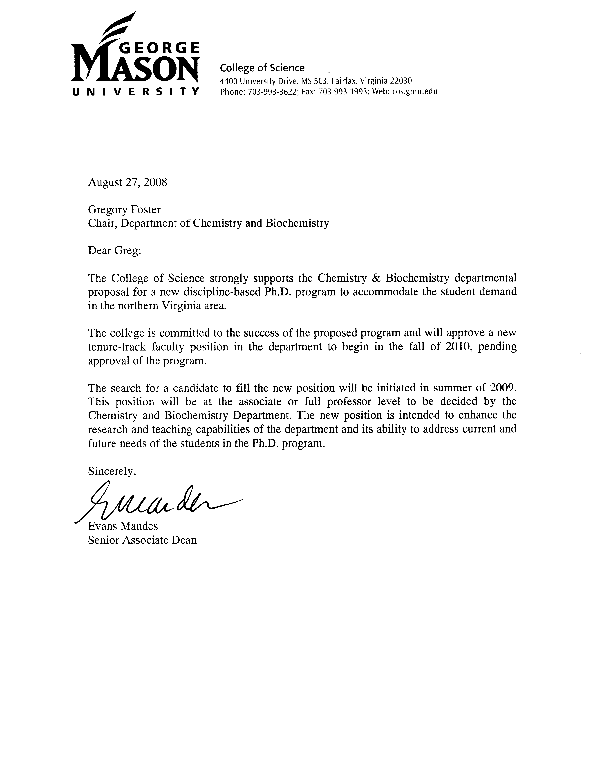

Appendix B– Sample Schedules for a Ph.D. in Chemistry and Biochemistry

Sample Biochemistry Student Schedule (Full-time each year)
Year | Fall | Spring | Yearly Credits | Cumulative
Year 1 | CHEM 665 | CHEM 791 | 22 | 22
 | CHEM 617 | CHEM 646
 | CHEM 660 | CHEM 651
 | CHEM 568 | CHEM 790 (1)
Year 2 | CHEM 661 | CHEM 567 | 20 | 42
 | CHEM 662 | CHEM 613
 | CHEM 796 (3) | CHEM 796 (3)
 | CHEM 790 (1) | CHEM 790 (1)
Year 3 | CHEM 796 (3) | CHEM 796 (3) | 12 | 54
 | CHEM 998 (3) | CHEM 998 (3)
Year 4 | CHEM 999 (9) | CHEM 999 (9) | 18 | 72

Sample Biochemistry Student Schedule (Part-time first three years; full-time rest)
Year | Fall | Spring | Yearly Credits | Cumulative
Year 1 | CHEM 665 | CHEM 791 | 12 | 12
 | CHEM 617 | CHEM 646
Year 2 | CHEM 660 | CHEM 651 | 15 | 27
 | CHEM 661 | CHEM 567
 | CHEM 790 (1) | CHEM 796 (1)
 |  | CHEM 790 (1)
Year 3 | CHEM 662 | CHEM 613 | 15 | 42
 | CHEM 796 (3) | CHEM 568
 | CHEM 790 (1) | CHEM 796 (2)
Year 4 | CHEM 796 (3) | CHEM 796 (3)
 | CHEM 998 (3) | CHEM 998 (3) | 12 | 54
Year 5 | CHEM 999 (9) | CHEM 999 (9) | 18 | 72

Appendix C – “Mini CV’s” for Faculty

Born, Timothy Lee, Associate Professor of Chemistry and Biochemistry. BS 1990, Calvin College; Ph.D. 1996, Mayo Graduate School. Biochemistry and enzymology, identification of novel antibacterial targets.

Bishop, Barney M., Assistant Professor of Chemistry and Biochemistry. BS 1991, College of William and Mary; Ph.D. 1997, University of North Carolina, Chapel Hill; Biochemistry, Protein/peptide engineering. Antimicrobials, Nanoparticle Design.

Cooper, Paul David, Assistant Professor of Chemistry and Biochemistry, BSc(Hons) 2000, Ph.D. 2005, The University of Western Australia; Spectroscopy, planetary surface chemistry.

Couch, Robin D., Assistant Professor of Chemistry and Biochemistry. BS 1994, University of Calgary; Ph.D. 2000, University of Calgary; Biochemistry, Protein Chemistry, Enzymology, Fungal Secondary Metabolism, Isoprene Biosynthesis, Antimicrobials.

Cozzens, Robert Francis, Professor of Chemistry and Biochemistry. BS 1963, Ph.D. 1966, University of Virginia. Physical chemistry, effects of laser radiation on materials, thermal stability of resins and composite materials, nonlinear optical materials.

Davies, Keith M., Professor of Chemistry and Biochemistry; B.Sc 1964, Ph.D. 1967, University of Wales; Bioinorganic Chemistry, Nitric Oxide Biochemistry.

Foster, Gregory D., Professor of Chemistry and Biochemistry (Chair); BS 1978, UC Davis; MS 1981, Cal-State Hayward; Ph.D. 1985, UC Davis. Environmental Chemistry; identification of sources, reactions, transport and public health assessment of organic micro-pollutants in aquatic environments

Hatton, Kimi, Term Associate Professor of Chemistry and Biochemistry. BS 1979, George Mason University; Ph.D. The Ohio State University, Columbus, OH 1979-1983 Ph. D., 1983, Biochemistry Biological chemistry, chemical biology of living systems, molecular biochemistry, cancer, normal development.

Honeychuck, Robert, Associate Professor of Chemistry and Biochemistry. BS 1977, Ohio State University; MS 1982, Ph.D. 1984, Michigan State University; Organic chemistry, polymer chemistry, nuclear magnetic resonance spectroscopy.

Hussam, Abul, Professor of Chemistry and Biochemistry. BSc 1975, MSc 1976, University of Dacca; Ph.D. 1982, University of Pittsburgh. Analytical chemistry, electroanalytical chemistry, thermodynamic properties of organized media.

Khan, Shahamat U., Research Affiliate Professor, Chemistry and Biochemistry. BSc 1957, Agra University, India; MSc 1959, Ahgarh Muslim University, India; MSc 1964, PhD 1967, Alberta University, Canada. Development of analytical techniques applicable to residues of pesticides and other organic pollutants in the environmental, biological and food samples.

Kort, David A., Term Assistant Professor of Chemistry and Biochemistry; BS 1991, Hope College; Ph.D. 1997 Purdue University. Inorganic Chemistry; Synthesis and characterization of compounds containing metal-metal multiple bonds, small molecule activation and functionalization, redox properties of metal-metal multiply-bonded compounds of the late transition series.

Mose, Douglas, Professor of Chemistry and Biochemistry. BS 1965, University of Illinois; MS 1968, Ph.D. 1971, University of Kansas. Geochemistry, Environmental science, geochemistry, air-water-soil site assessments, hazmat management.
Mushrush, George William, Professor of Chemistry and Biochemistry; BS 1962, Indiana University of Pennsylvania; MS 1965, Ph.D. 1968, George Washington University. Fuel science, biofuels, energy transfer, organic, synthesis, environmental contamination.

Pettigrew, Kathy Term Assistant Professor of Chemistry and Biochemistry, Ph.D. 2004 UC-Davis, Solution synthesis and characterization of silicon and silicon/germanium.

Schreifels, John A., Associate Professor of Chemistry and Biochemistry; BS 1975, Ph.D. 1979, University of South Florida; Surface Chemistry. Catalysis. Corrosion. Electronic Materials.

Slayden, Suzanne Weems, Associate Professor of Chemistry and Biochemistry. BS 1970, Ph.D. 1976, University of Tennessee. Organic chemistry, physical organic, thermochemical energetics and systematics.

Weatherspoon, Gerald L., Associate Professor of Chemistry and Biochemistry (Associate Chair). BS 1984, Jackson State University; Ph.D. 1995, University of California, Davis. Solid state inorganic Chemistry. Inorganic and solid state chemistry, synthesis and characterization of new materials, structural, electronic, and magnetic properties.

Appendix D – Departmental Faculty Research

There are currently a number of areas of active research in the Department of Chemistry and Biochemistry, several of which are funded by external grants.
- Water sustainability and purity (Foster, Hussam)
- Biochemistry (Bishop, Born, Couch)
- Fuels, synthesis and stability (Mushrush)
- Astrophysical Chemistry (Cooper)
- Solid state synthesis of novel inorganic oxides (Weatherspoon)
- Materials Chemistry (Cozzens)
- Bioinorganic (Davies)
- Organic Chemistry (Honeychuck)
- Surface Chemistry (Schreifels)
- Geochemistry (Mose)
Barney Bishop is a bioorganic chemist. His research is primarily focused on antimicrobial peptides and engineering nanoparticles, with the common theme throughout his research being molecular design. Antimicrobial peptides represent an ancient defensive mechanism utilized by most higher organisms to fend off invading microbes. With the increasing challenge of antibiotic resistance, there is an urgent need for new approaches for treating bacterial infections. Dr. Bishop is interested in studying the biophysical and antimicrobial properties of these peptides and devising novel strategies for utilizing this information in the design of antimicrobial therapies. This project has benefited from an active collaboration with Dr. Monique van Hoek in the Center for Biodefense and Infectious Disease at George Mason University. In the area of nanoparticles, Dr. Bishop is interested in engineering environment responsive nanoparticles for the selective sequestration of assorted classes of compounds from complex solutions. Such technologies have immediate medical and environmental applications.

Timothy Born has long been intrigued by enzymes; he finds their catalytic power and specificity never cease to amaze him and his primary interest lies in understanding enzyme catalytic mechanisms. He has applied his interest in enzymology to a larger health problem: the development of bacterial resistance to all currently used antibiotics. There are many ways to combat this problem, one of which is to identify new targets for the design of novel antibacterial compounds. His group has begun investigating the two enzymes responsible for the first unique step in methionine biosynthesis, acylation of homoserine. They are in the process of enzymatically characterizing these proteins and have begun experiments aimed at 3-D structure determination. His ultimate goal is to use this mechanistic and structural information in the rational design of inhibitors that may lead to new classes of antibiotics.

Paul Cooper is an experimental physical chemist. His two principal areas of interest are infrared matrix-isolation spectroscopy and the chemistry of astrophysical ices. In the field of matrix isolation spectroscopy, he researches hydrogen-bonded systems, particularly those involving water molecules. Complexes of water molecules are nearly universally important due to the widespread presence of water, but are particularly important in atmospheric chemistry. The study of the bonding between free radicals and water is also potentially important for biological systems. His second area of interest includes the radiation chemistry and properties of ices. Through laboratory experiments, the physical and chemical process occurring on planetary surfaces are simulated. Spectroscopic data can then be used to support astronomical observations. Collaborative ties in this area include NASA Goddard Space Flight Center and the Jet Propulsion Laboratory.

Robin Couch is a biochemist. His research is primarily focused on proteins and natural products of pharmaceutical interest. His lab is currently investigating several enzymes involved in isoprene biosynthesis in Francisella tularensis. This bacterium has been identified by the CDC as a biothreat agent, and the enzymes of the isoprene biosynthetic pathway are promising targets for the development of novel antibiotics. His research group is also investigating a key enzyme in human cholesterol biosynthesis. His studies are designed to elucidate the structural features of this enzyme that are responsible for interpatient differences in response to anticholesterol drugs. The Couch lab is also studying cyathin A₃, an isoprene natural product produced by the fungus Cyathus helenae. The cyathane family of molecules have been shown to stimulate nerve growth factor release from astroglial cells and therefore have promise for use in the treatment of neurodegenerative disorders such as Alzheimer’s and Huntington’s disease.

Robert Cozzens’ interests include: material science, photochemistry, effect of lasers on materials, microwave induced chemistry, and nonlinear optical materials. He is actively involved in research jointly with the Department of Defense and periodically serves as an expert witness in several patent cases involving spectroscopy and material science of optical materials.

Keith Davies is a bioinorganic chemist with particular interests in the area of nitric oxide biochemistry. Currently his research activities are centered on diazeniumdiolates, a class of NO providers widely used in biomedical research studies both in ionic forms that undergo acid catalyzed dissociation at physiological pH and as protected prodrugs that are stable until activated for NO release by enzymes at targeted biological sites. Present activities at GMU are centered on the use of phospholipid liposomes and surfactant vesicles as model membrane systems for the study of environmental factors influencing NO release. Recent research funding from NHLBI and NIGMS has supported studies of diazeniumdiolate reactivity in lung surfactant and other biomimetic reaction media. He continues to collaborate with the Nitric Oxide Research group at the NCI (http://home.ncifcrf.gov/lcc/nitricoxide), particularly on rate and mechanistic aspects.

Gregory D. Foster is an environmental analytical chemist. Dr. Foster is the director of the environmental chemistry laboratory at George Mason University. His primary research interests are in the sources, reactions, transport and public health assessment of organic micro-pollutants in aquatic environments. Current research is focusing on urban regions as sources of organic contaminants to coastal air- and watersheds in the Chesapeake Bay region, developing technologies to remediate water pollutants that impact human health, and developing new analytical methods of measurement at ultra-trace levels. Existing projects are devoted to quantifying organic substances, primarily pollutants such as polycyclic aromatic hydrocarbons and polychlorinated biphenyls, in urban runoff entering the Potomac River (Washington, DC) watershed, using molecular marker compounds to identify sources, assessing filtration technologies that remove micro-pollutants in water, and developing new HPLC/MS and GC/MS analytical methods for the detection and quantification of pharmaceuticals and personal care products in water.

Robert Honeychuck is active in organic chemistry, polymer chemistry, and nuclear magnetic resonance. He synthesizes analogs of bacterial membrane constituents. These analogs are typically functionalized on a side chain, for purposes of attachment to inorganic or organic substrates, or for incorporation into a polymer backbone structure. Part of his work is directed towards understanding the normal function of the naturally occurring membrane constituents in bacteria, and part towards using these and similar compounds against other classes of bacteria. He is also the director of the nuclear magnetic resonance laboratory, and maintains the Department of Chemistry and Biochemistry’s superconducting 300 MHz Fourier transform nuclear magnetic resonance instrument, and trains new users on it. The instrument, a liquids Bruker DPX 300, has multinuclear and variable temperature capabilities. He is actively seeking well-qualified graduate students to expand the range of available bacterials and bacterial analogs, and to aid in the transition to a state of the art operating system and NMR program on the DPX 300.
Abul Hussam has been involved in the development of electroanalytical techniques for the study of toxic species in the environment. He is particularly interested in the aquatic chemistry of arsenic in groundwater and the development of inexpensive water filters. He has developed a field electrochemical technique to measure parts-per-billion level of arsenic species in groundwater and has also devised a simple filter (SONO filter) to purify groundwater from toxic arsenic species. The innovation was awarded the 2007 National Academy of Engineering- Grainger Challenge Prize for Sustainability the gold medal and one million dollar. More than 30,000 such filters are in use in Bangladesh producing more than a billion liter of safe drinking water for the affected people. He has also extended the use of electrochemical techniques to understand the diffusion behavior and electron transfer kinetics of lipophilic redox species in organized media such as micelles and microemulsions. To complement these studies his group has built a high precision headspace gas chromatograph and using solid phase microextraction to study the partitioning of volatile species in ambient atmosphere and in organized media. (extended profile)

Douglas Mose and George Mushrush have been examining the variability of radioactivity in air and water. The radioactivity is a known carcinogen, and is present as isotopes of radon and polonium. Their studies have shown that airborne radioactivity in homes is significantly greater than average in homes located in the western part of Fairfax County, and that in all homes, the indoor airborne radioactivity is significantly increased during rainstorms. They also found that homes with cinder block basement walls and oil or gas furnaces tend to have more indoor radioactivity than homes with poured concrete walls and electrical heat. Recently Mose and Mushrush traveled to Poland as part of an international study of radioactivity, and made similar discoveries because soils in Poland and Virginia are generally similar. Their studies on drinking water have shown that radioactivity is present in drinking water provided by water wells, and that most of the Fairfax County water wells are 5-10 times as radioactive as the maximum recommended by the US Environmental Protection Agency (EPA). They have examined enough homes to determine which bedrock materials are of particular concern, and they experimented with several methods of radioactivity removal from water and developed an inexpensive nearly 100% removal technology. Drs. Mose and Mushrush, and their students, have been studying steam contamination by heavy metals in Prince William Forest National Park, to determine if current remediation efforts are successful. They are also monitoring the deposition in rainfall of mercury in central Virginia. Mercury is a toxic heavy metal, most of which originates from coal-burning power stations. Mose and Mushrush operate part of the mercury deposition network supported by EPA/DOE/USGS scientists.

George William Mushrush is a physical, inorganic chemist. He is studying methods to synthesize and characterize shale crude oil components and their thermal reactions. He is also synthesizing fuel system icing inhibitors and wing deicers and hydroperoxides and studying their thermal reactivity, product distribution during metal surface or metal ion catalysis. In collaboration with Douglas Mose, he is studying indoor radon, its significance as a natural pollutant and its regional occurrence in Virginia and Maryland.

John A. Schreifels is an experimental surface chemist. His research involves the study of the adsorption of moderately sized molecules on clean metal surfaces to determine the nature of the interaction of the molecule with the surface. The electronic environment is studied using X-ray Photoelectron Spectroscopy (XPS) and Temperature Programmed Desorption (TPD) techniques. We have developed a method of acquiring data, which makes it possible to acquire more data in one experiment than was taken in 10 to 100 experiments prior to this development. Additionally, in collaboration with Electrical Engineering investigators, XPS and Auger depth profile studies of electronic materials such as gallium nitride and silicon carbide was performed to characterize the response of these materials to ultra fast heat – heating a sample to anneal out defects at a rate of several hundred degrees per second.

Gerald Weatherspoon is interested in solid state synthesis and characterization of La_{6.4}Ca_{1.6}Cu_{8-x}Pd_{x}O₂₀ and Y_{2-x}Ce_{x}Ti₂O₇. He has also worked on new mixed oxide materials as bifunctional electrodes and dielectrics. He has studied the magnetic properties of 8-8-20 mixed-metal oxides and oxygen evolution and reduction studies of bifunctional 8-8-20 oxide electrodes.

Appendix E – Sample Survey Instrument

Graduate Student Survey
Last Name: ______________________ First Name: _______________________
Gender:  Male  Female
What is your current Program at GMU? _________________________
In what year you first enrolled in Program? ______________________
Number of grad credits earned (including current semester): ______________________
Current Graduate GPA: ______________________
Graduate status at GMU:  Full time (FT) or  Part time (PT)
Please indicated whether you are currently supported by a:  GTA  GRA  N/A
Department where GTA/GRA is held: __________________________________________
Institution where you received your BS/BA: __________________________________________
Year that you obtained your BS/BA: ______________________
Undergraduate GPA: ____________________

For students that have already received a MS/MA degree:
MS/MA program of study: __________________________________
Institution where you received your MS/MA: _________________________________________
Year that you obtained your MS/MA: ______________________
MS/MA GPA: ____________________

For students that have external employment:
External employment:  Part time  Full time  N/A
Name of external employer: _________________________________________
Does your employer pay for graduate studies:  Yes  No

Would a Doctoral degree in Chemistry help you in your work?  Yes  No
Students in a Ph.D. program, you advanced to candidacy?  Yes  No
Estimated number of years to candidacy or Ph.D./MS completion: ______________________
Are you currently doing research with GMU faculty?  Yes  No
If yes: Topic of research: _______________________________________________
Name of faculty member: _________________________________________
What are your future plans after Ph.D./MS
 Graduate School  Academic Position  Industry  Other

Students in a MS/MA program at George Mason University:
If George Mason University offered a Doctoral program in Chemistry, would you be likely to enroll in such a program?  Yes  No
All Students:
Would you prefer the title of your Ph.D. to be:
 Physics  Chemistry  Physical Sciences  Chemistry and Biochemistry  Other
Please write any comments on back:

Appendix F – List of Ph.D.s Granted with Chemistry Department Advisor

Name | Year | Program
Chusuei, Charles | 1997 | ESPP
Merolla, Paul | 1998 | ESPP
Bliss, Malcolm | 1999 | ESPP
Wynne, James | 2000 | ESPP
Al-Hothali, Faisal | 2000 | ESPP
Hughes, Janet | 2001 | ESPP
Pollio, Carol | 2001 | ESPP
Doelling-Brown, Paige | 2001 | ESPP
Eckel, William | 2001 | ESPP
Komelasky, Michael | 2003 | ESPP
Walls, Cassi | 2004 | ESPP
McEachearn, Philip | 2005 | ESPP
Pant, Ramesh | 2006 | PSCI
Haque. Muhammed | 2007 | ESPP
Simoni, Fiorella | 2007 | ESPP
Bauserman, Joy | 2007 | ESPP

Appendix G. – Letters of Support from Current and Admitted PSCI Ph.D. students

Letter from Girija Bharat first year student
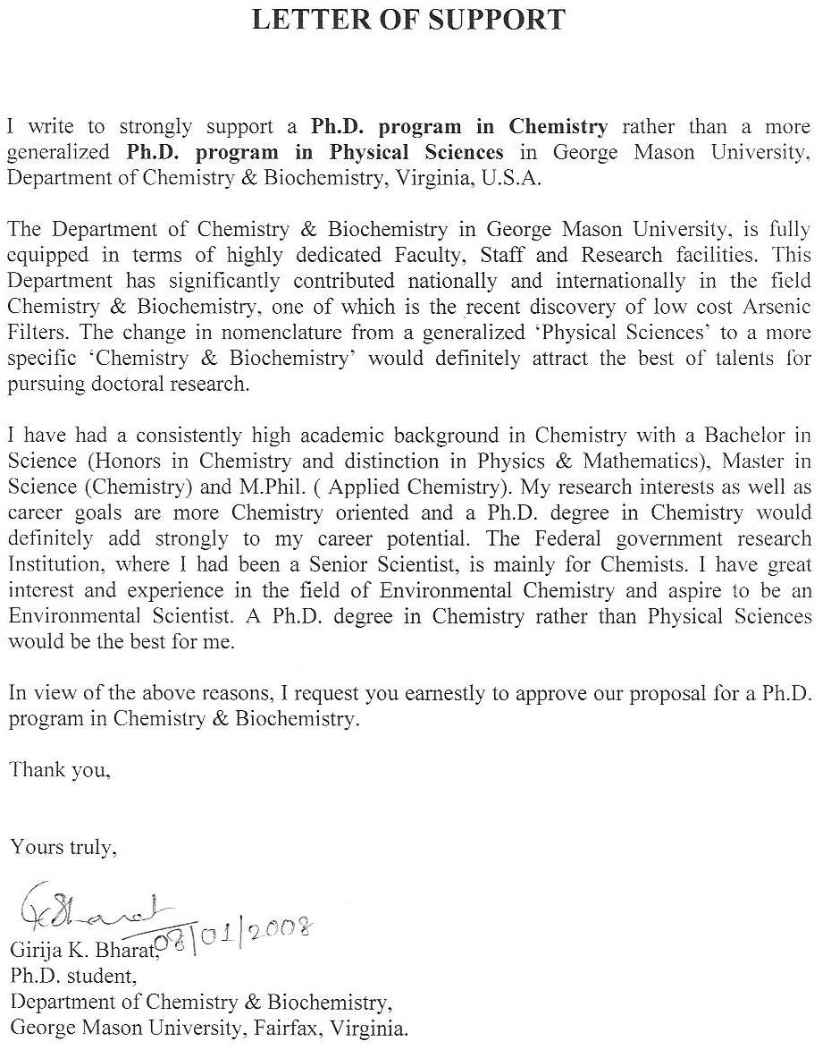

Letter from Nhut Do third year student
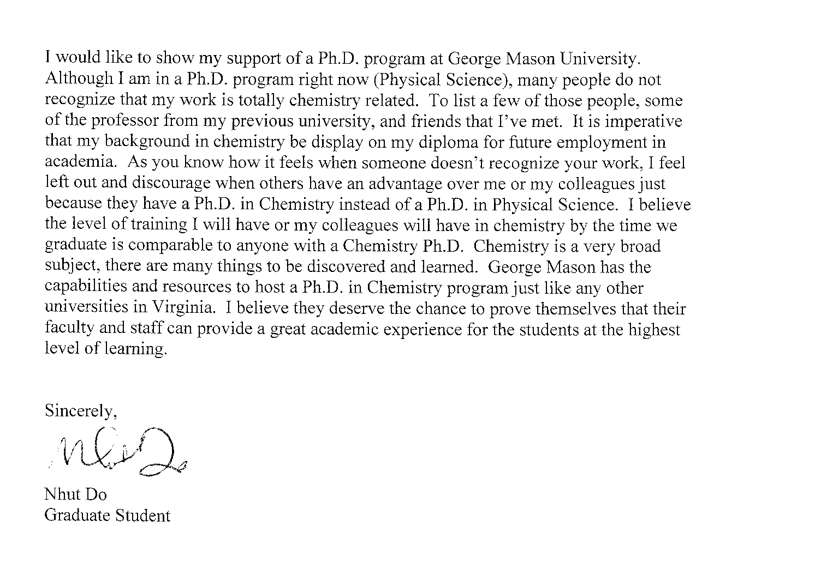
Letter from Maryam Goudarzi third year student
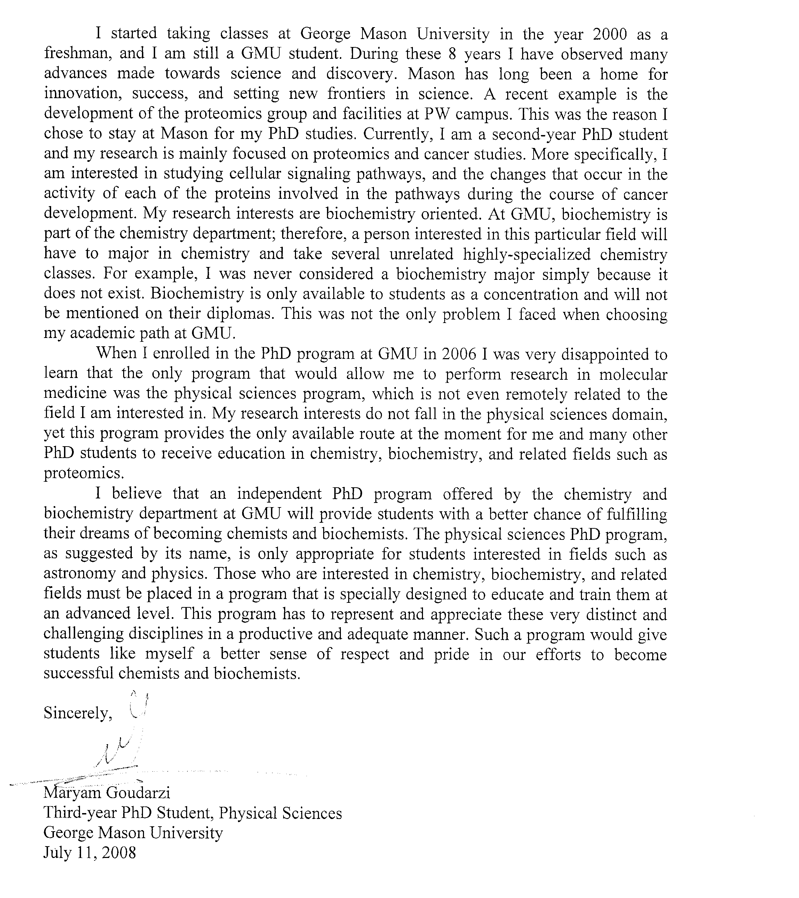
Letter from Jaykumar Patel first year student
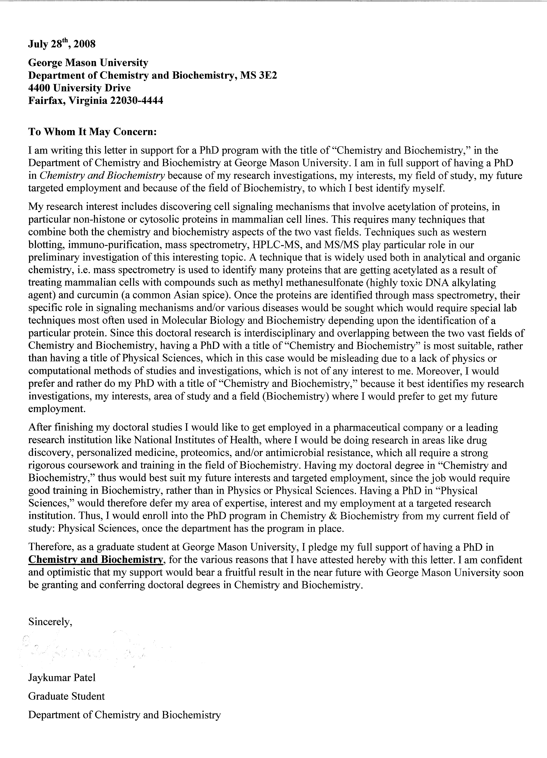
Letter from Douglas Mays fourth year student

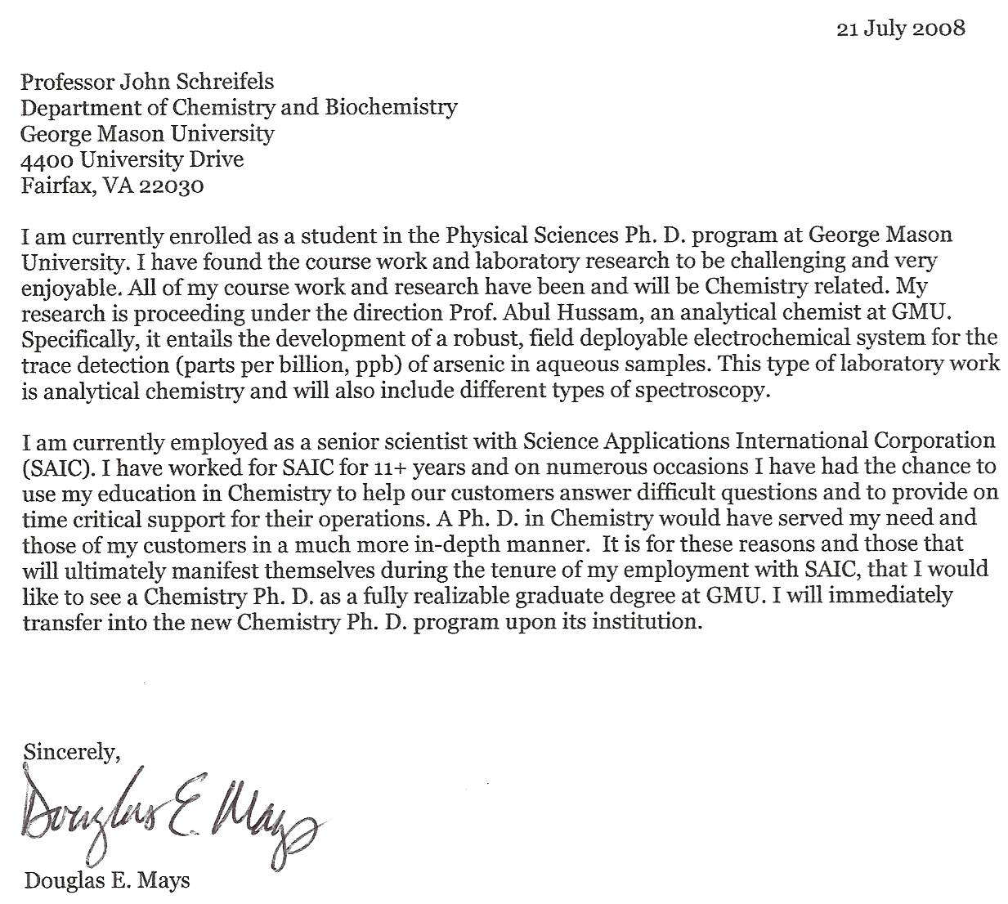

Letter from Lirije Alić first year student
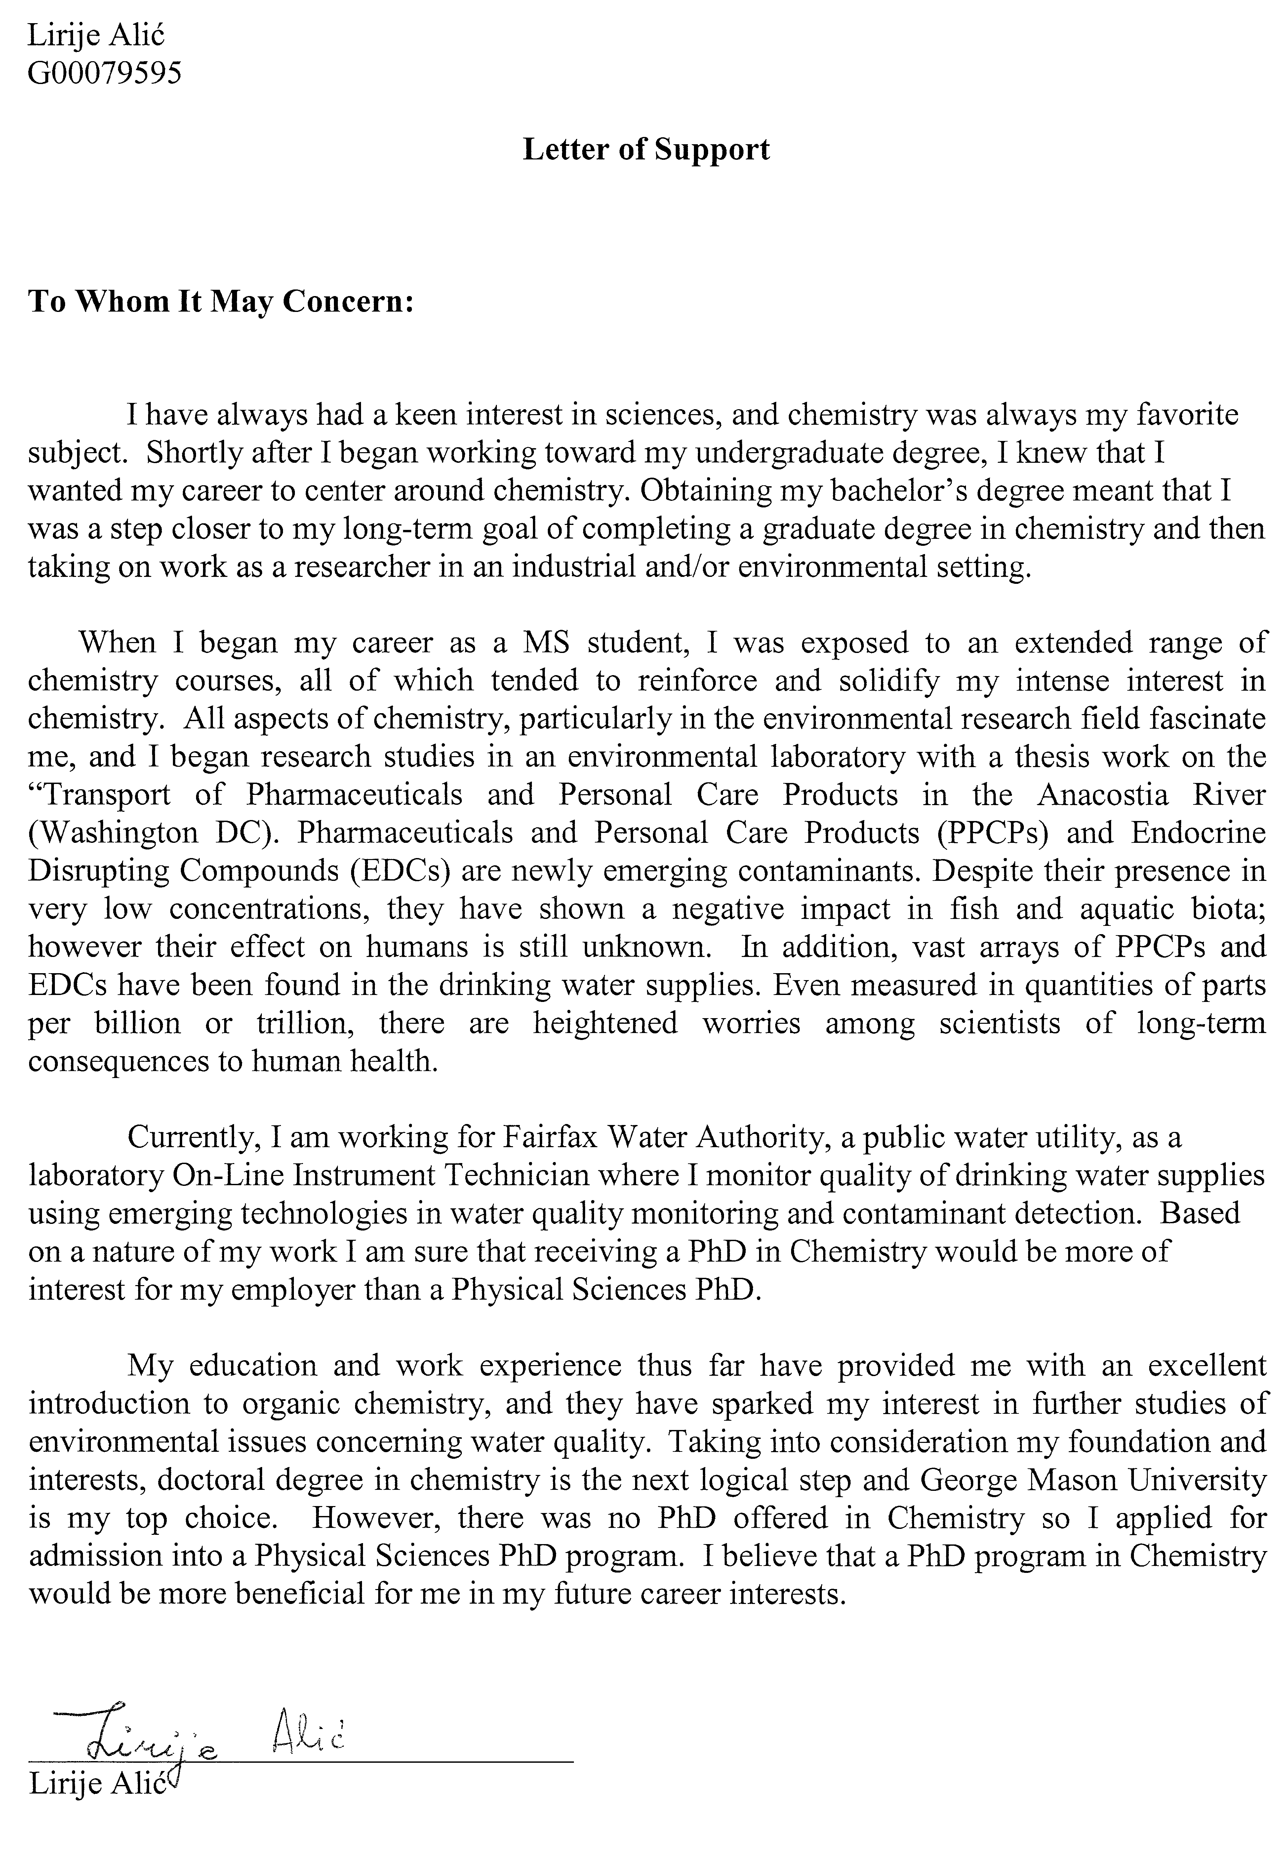
Letter from Christopher Lloyd third year student
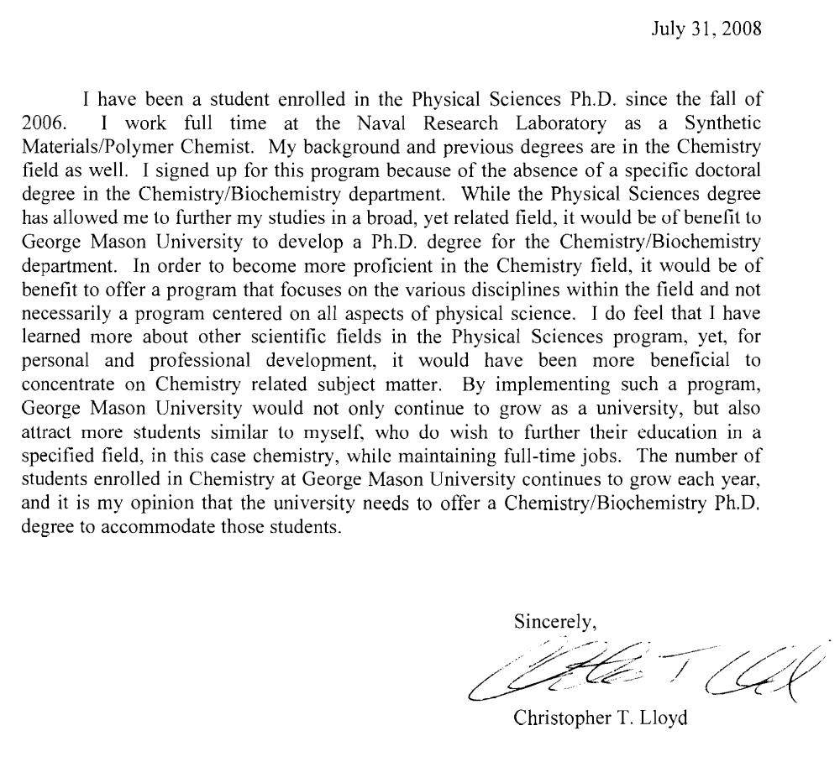
Letter from Alexis Patanarut second year student
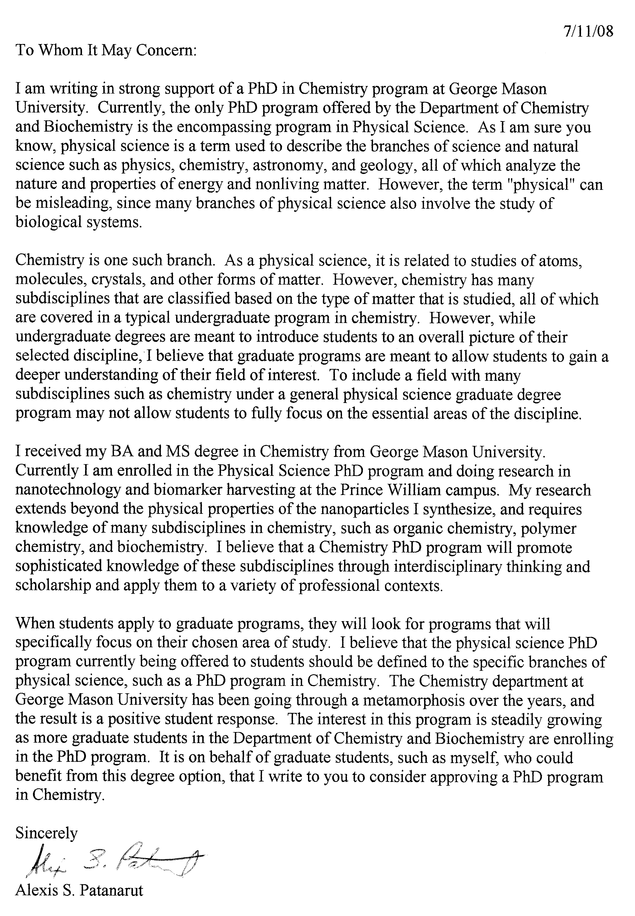

Appendix H – Letter of support from Alumni
Letter from Charles Chusuei GMU Ph.D. 1997
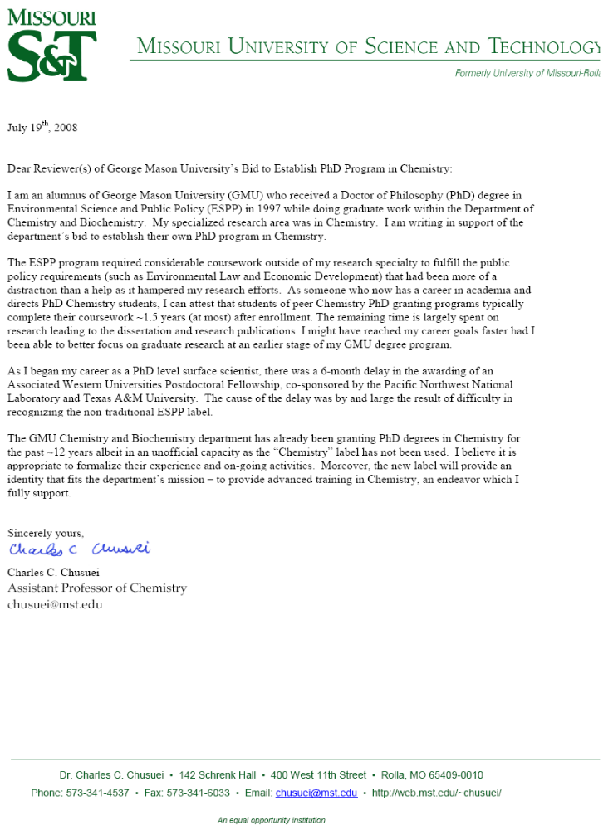

Appendix I – Job Announcements below.

Adapted, in part, from http://www.bls.gov/oco/
http://www.bls.gov/oes/current/oessrcma.htm
U.S. Department of Labor, Bureau of Labor Statistics (http://data.bls.gov/oep/servlet/oep.noeted.servlet.ActionServlet?Action=empoccp
Virginia Workforce Connection – Occupational Employment Projections http://www.vawc.virginia.gov//analyzer/searchAnalyzer.asp?cat=OCC&session=OCCPROJ&subsession=99&areaname=&time=&geo=5101&blnStart=True

